* 1. Set Up and Create a Git Repository



This section will guide you to:

* Download Git from the official site and configure it
* Generate files, initialize .git directory, and commit the files

This guide has four subsections, namely:

* + 1. Downloading Git from the official site for your operating system
    2. Configuring Git in your system
    3. Generating files and initializing the .git directory
    4. Executing the basic commands

**Git is already installed in the labs**

**If you want to use Git using software then use the following steps:**

**Step 1.1.1:** Downloading Git from the official site for your operating system

Open your Chrome browser and navigate to <https://git-scm.com/downloads> page of Git. Click on the **Download <Version_Number> for Windows** button available on the right side of the screen as shown in the screenshot below:

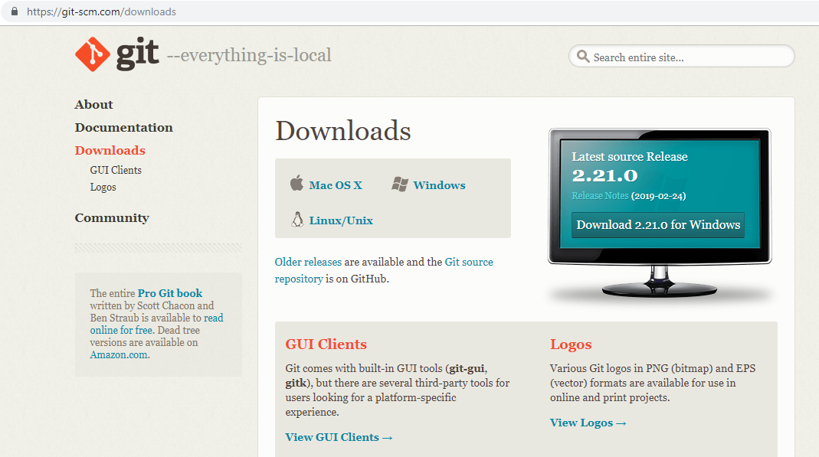

**Step 1.1.2:** Configuring Git in your system

* Locate the downloaded git.exe file.
* [right-click] on the executable git file and select **Run as administrator.**
* Once you accept the installation request, you will be directed to the **Information** window. Click on the **[Next >]** button.
* Do not make any changes and click on the **[Next >]** button.
* You will be prompted to select the default editor used by Git. Select **Use Vim (the ubiquitous text editor) as Git’s default editor** and click on the **[Next >]** button.
* You will be prompted to select how to use Git. Select **Git from the command line and also from 3rd – party software** and click on the **[Next >]** button.
* You will be prompted to select the HTTPS transport backend. Select **Use the OpenSSL library** and click on the **[Next >]** button.
* You will be prompted to select a style to treat the line endings in text files. Read the options and select one per your preference. Click on the **[Next >]** button.
* You will be prompted to select the terminal emulator. Read the options and select per your preference. Click on the **[Next >]** button.
* You will be prompted to choose the features to enable. Do not make any changes and click on the **[Install]** button.

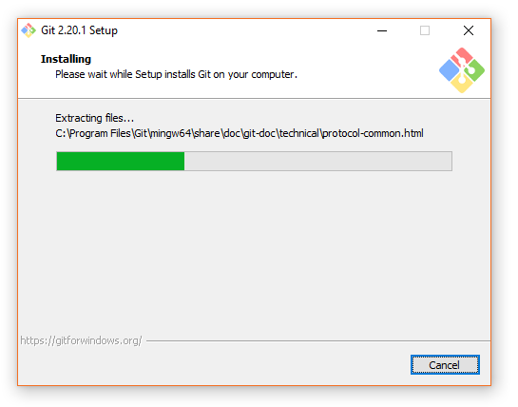

**Step 1.1.3:** Generating files and initializing the .git directory

* Create a folder on your desktop and open it.
* Create the files: hello.js, index.html, and helloWorld.java.
* Open the Git terminal and navigate to the folder you have created.
* Execute the following command to initialize the .git repository:

git init

**Step 1.1.4:** Executing the basic commands.

Add all the files to your git repository using the following command:

git add .

Commit the changes using the following command:

git commit -m . “Changes have been committed.”